## SQL Assignment : Product Table

**Objective**

This Assignment will help you practice creating a Products table, Inserting data, Updating data and performing various queries.

**Instructions**

**1. Creating the Table:** Write a SQL statement to create the Products table with the following structure:

* ProductID (integer, primary key, not null)
* ProductName (nvarchar(50), not null)
* Category (nvarchar(50), not null)
* Price (decimal(10,2), not null)
* StockQuantity (integer, not null)

**2. Insert Records:** Insert the following records into the Products table:

* (1, 'Laptop', 'Electronics', 1000.00, 50)
* (2, 'Headphones', 'Electronics', 150.00, 200)
* (3,'Coffee Maker','Home Appliences', 80.00, 100)
* (4,'Blender','Home Appliences', 120.00, 80)
* (5,'Office Chair','Furniture', 250.00, 30)

**3. Insert One More Record:** Insert the additional record:

* (6, 'Desk Lamp', 'Furniture', 250.00, 150)

**4. Select All Records :** Write a SQL statement to select all records from the Products table.

**5. Select Specific Columns :** Write a SQL statement to select the ProductName and Price columns from the Products table.

**6. Where Clause :** Write a SQL statement to select all products in the ‘Electronics’ category.

**7. Order By :** Write a SQL statement to select all products and order them by Price in ascending order.

**8. Aggregade Function (COUNT) :** Write a SQL statement to count the number of products in the Products table.

**Solutions :**

**1. Creating the Table** : we can use below SQL statement to create table -

CREATE table products (

ProductId INT PRIMARY KEY NOT NULL,

ProductName NVARCHAR(50) NOT NULL,

Category NVARCHAR(50) NOT NULL,

Price decimal(10,2) NOT NULL,

StockQuantity INT NOT NULL );

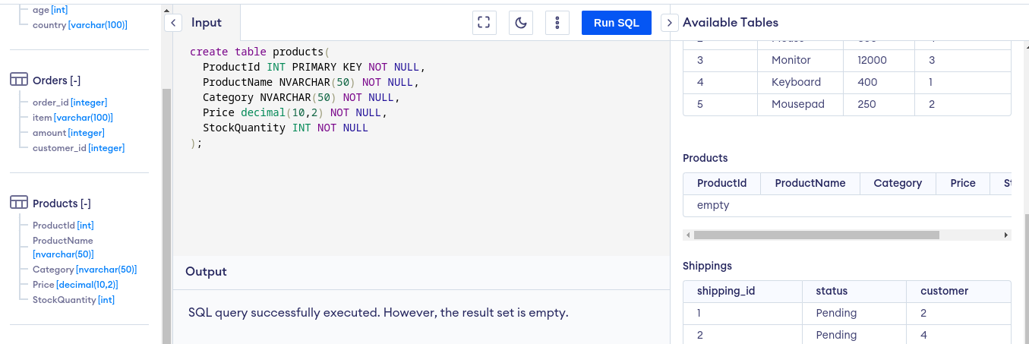**2. Insert Records :**

to insert data in products table we can use below SQL statement -

INSERT INTO products (ProductId,ProductName,Category,Price,StockQuantity) VALUES

(1, 'Laptop', 'Electronics', 1000.00, 50),

(2, 'Headphones', 'Electronics', 150.00, 200),

(3,'Coffee Maker','Home Appliences', 80.00, 100),

(4,'Blender','Home Appliences', 120.00, 80),

(5,'Office Chair','Furniture', 250.00, 30) ;

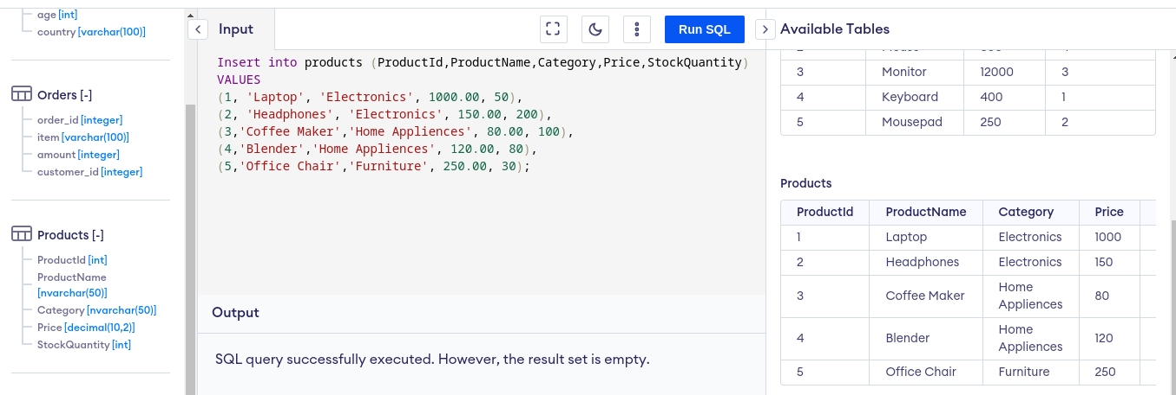

**3. Insert One More Record :**

INSERT INTO products (ProductId,ProductName,Category,Price,StockQuantity) VALUES (6, 'Desk Lamp', 'Furniture', 250.00, 150);

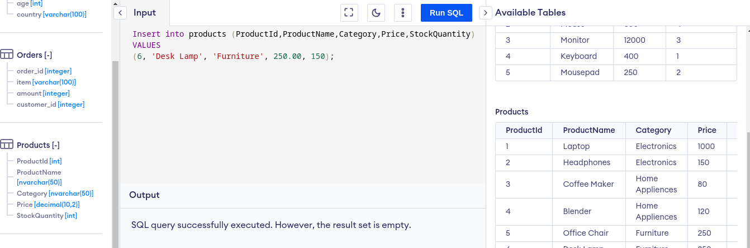

**4. Select All Records :** SELECT * FROM products;

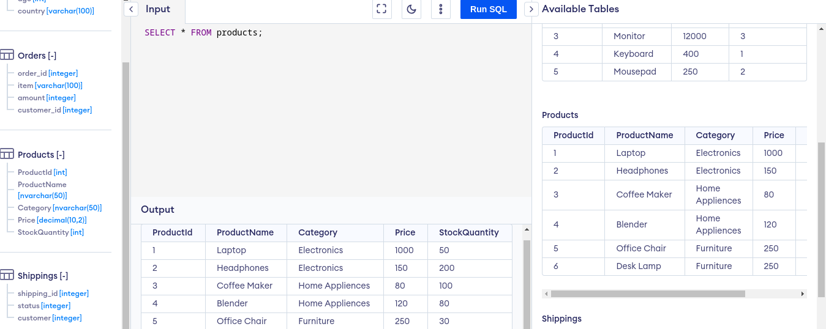

**5. Select Specific Columns :** SELECT ProductName, Price FROM products;

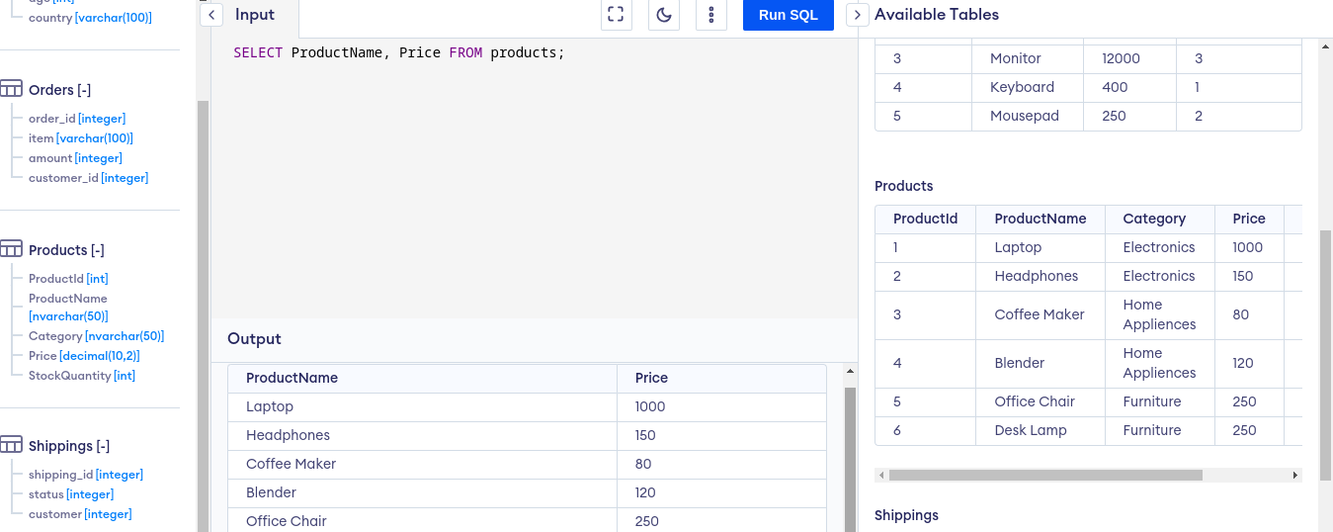

**6. Where Clause :** SELECT * FROM products where Category = 'Electronics' ;

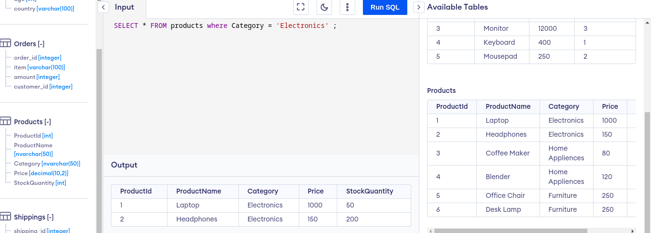

**7. Order By :** SELECT * FROM products order by Price asc;

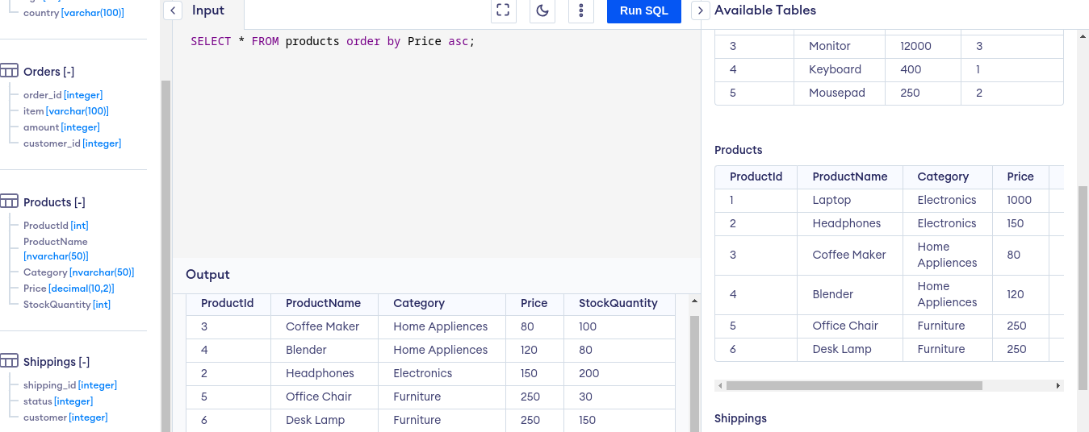

**8. Aggregade Function (COUNT) :** SELECT count(*) AS Number_of_Products from products;

